

Creative Engagement Social Media and Communications
Internship
June 2025


WELCOME

Thank you for your interest in the role of
Creative Engagement Social Media and Communications Intern at HOME.

HOME is Greater Manchester’s vibrant cross art form centre. We commission, create and present contemporary theatre, visual art and film and provide a space for experimentation where art forms meet and interconnect. HOME’s programming is political, international and experimental.

HOME first opened its doors in May 2015: a new, £25m multi-art form venue for Manchester, operated by Greater Manchester Arts Centre (GMAC). Since opening, we have welcomed over 4 million visitors and contributed over £101 million to the Greater Manchester economy.

We became one of the few UK organisations to produce new work across theatre, visual art and cinema, achieving local, national and international artistic recognition.

Our programme is presented across:
- Five state-of-the-art cinemas, presenting one of the UK’s most celebrated programmes of independent film
- Two theatres – c.500 seat proscenium arch, T1; and c.130 seat flexible studio theatre, T2 – presenting HOME produced productions
- 500m² contemporary visual art space
- Digital platforms
- Talent development and engagement spaces
- In youth and education settings and within communities across Manchester

HOME also relies on trading and secondary income to support the charity, including two bars, a restaurant, event spaces and retail space.

If you require a large print version of this recruitment pack, or any reasonable adjustments to apply for this position, please contact recruitment@homemcr.org.

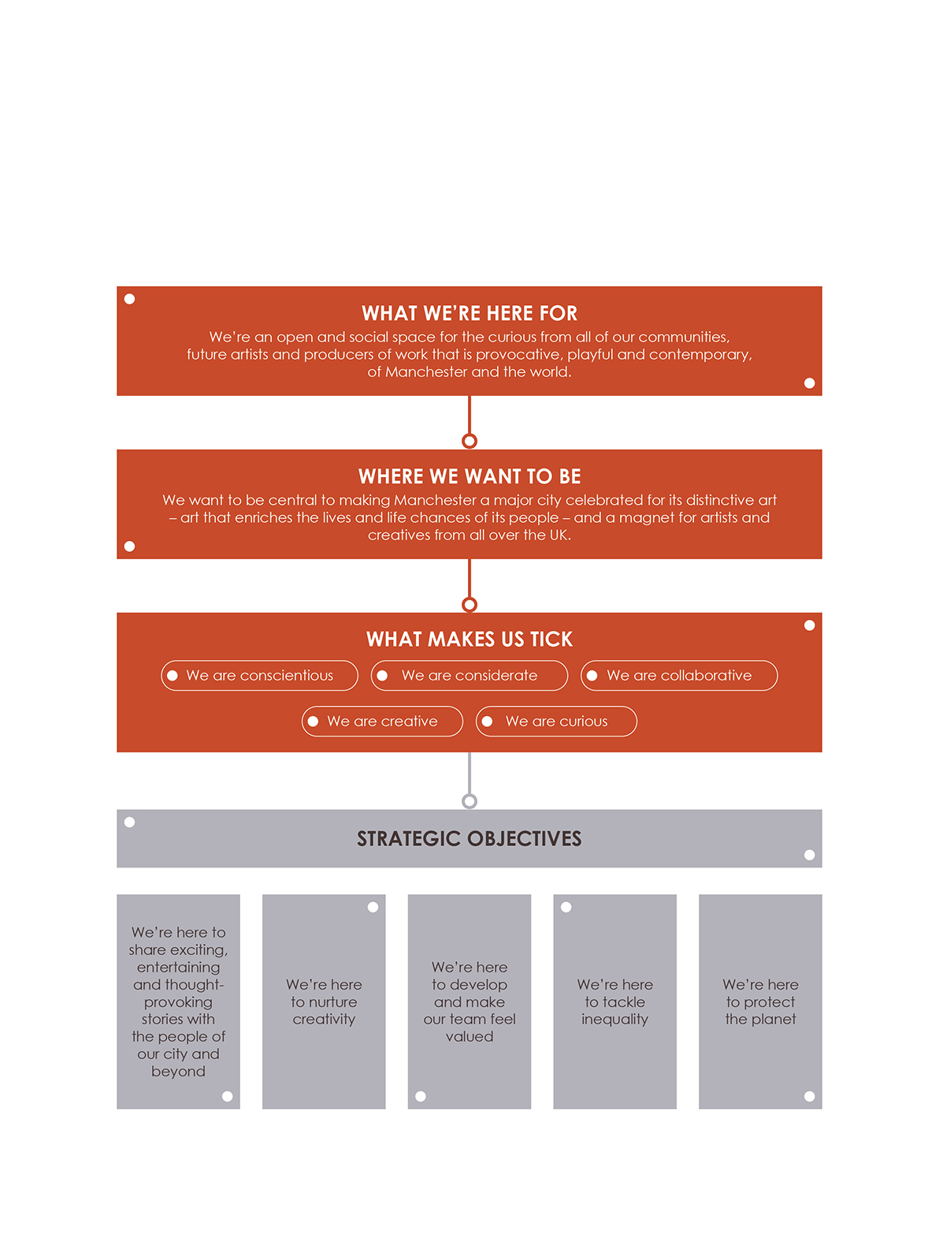
OUR VISION
& MISSION

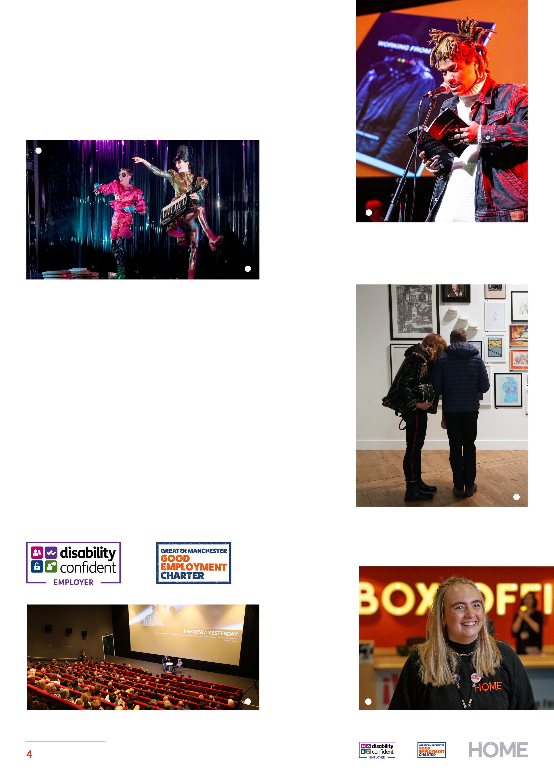

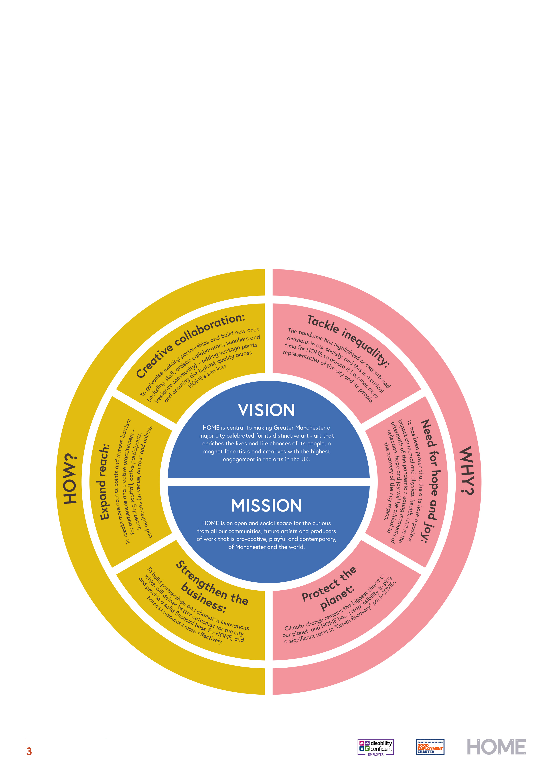

Equality at HOME

We want our workforce to reflect the diverse communities of Greater Manchester and we welcome candidates from all backgrounds. We actively encourage and support applications from groups who are currently underrepresented across the arts sector, including;
- Members of the Global Majority
- Individuals from lower socio-economic backgrounds
- Deaf, disabled and/or neurodiverse applicants
- People from the LQBTQIA+ community

HOME is a Disability Confident Employer, and a Supporter of the Greater Manchester Good Employment Charter.



KEY INFORMATION

Salary | National Living Wage  £12.60 Per Hour
Contract | Fixed Term, 16 Weeks (approx. 4 Months)
Hours of work | 12 hours per week, inclusive of meal breaks  Exact hours of work as required by the job. Overtime payments will not be made, however, time off in lieu (T.O.I.L), with the line manager’s agreement, will be available to cover any additional hours worked.
Holidays | 25 days pro rata
Pension | GMAC Ltd operates a company pension scheme with a 3% company contribution, that is available to all staff
Other benefits | Discounted cinema tickets  Discounted theatre tickets  Employee Assistance Programme  Discounts in the HOME shop and restaurant
Probationary period | 2 weeks
Notice period | 2 weeks


JOB DESCRIPTION
Purpose
As the Creative Engagement Marketing Intern, you would become part of the Creative Engagement team also working closely with the Marketing and Communications team. Creative Engagement strive to increase access to art and culture for young people, communities and schools. The aim of this internship is to create content and share stories that amplify the work of the Creative Engagement team. Platforming the authentic voices and artistic work created by young people and communities in Manchester.

Main duties
- To help the Creative Engagement and Marketing and Communications teams in planning, creating and sharing content for a variety of projects and events, including (but not limited to):
  - Community projects – such as Home from HOME
  - Schools and college events – such as school tours and A-level study days and the Linking Schools Project
  - Young Creatives sessions – Young Film Collective, Young Artist Studio, Young Company
  - Internships and Placements at HOME
- To assist in promoting projects through HOME’s website, social media, and email
- To work with the Development team (fundraising) to help create content which can be used for fundraising purposes
- To create photos, videos, emails and other promotional material
- To attend team meetings

More Details
- HOME requests flexibility for the individual to work occasional evenings and weekends (with advance notice) in line with the delivery of these events (HOME is mindful of any responsibilities outside of work and will aim to provide
3 weeks’ notice where possible to allow provisions to be made)
- HOME will provide safeguarding training to ensure you are equipped with the information required to work in these environments safely.
- HOME will complete a DBS check as part of your enrolment once appointed

PERSON SPECIFICATION

Essential skills & experience
 | Essential | Desirable
Attitude | Willingness to learn and ask questions  Interested in sharing stories in a variety of ways | A passion for inclusion  Interest in Theatre/ Film/ Visual art and working with communities, schools or colleges, and young people
Experience  personal, educational or employment experience are all valid | Experience in photographing and filming content  Using Canva or similar editing software  Experience of posting and using social media on a regular basis along with the latest social media trends | Experience of sharing stories to meet the needs/interests of audiences
Practical Skills | Previous use of Windows applications: Word, Excel, PowerPoint  Proficient reading and writing skills (proofreading will be provided and this position is suitable for those who may have challenges with spelling or grammar)  Familiarity with Outlook (or other email and calendar scheduling apps) | Use of a DSL camera  Use of photo/ video editing software

HOW TO APPLY

The deadline for applications is 11th August 2025 at 10am.

Email tiffany.bowman@homemcr.org with your:
- CV
- Cover Letter
- And please complete this online form (Don’t forget to click submit) Equal Opportunities Form

You can submit your cover letter as a video or audio if you prefer.

In the cover letter please ensure you provide examples of how you meet the criteria listed under the person specification for this role. This should be no longer than 1 A4 page (Size 12 font) or a video/ audio response no longer than 5 minutes in total.

Interviews will take place in person w/c 25th August 2025.
Interview questions will be shared in advance to allow you time to prepare.
Offers will be made the following week.

The start date for the position will be from the week commencing the 22nd of September 2025.

This will allow time for us to collect references and complete a DBS check.

Due to our team capacity, we will not be able to inform or provide feedback for applicants not selected for interview.

Thank you for your interest in this post.

