

BFI Film Academy Internship
June 2025


WELCOME

Thank you for your interest in the role of
BFI Film Academy Intern at HOME.

HOME is Greater Manchester’s vibrant cross art form centre. We commission, create and present contemporary theatre, visual art and film and provide a space for experimentation where art forms meet and interconnect. HOME’s programming is political, international and experimental.

HOME first opened its doors in May 2015: a new, £25m multi-art form venue for Manchester, operated by Greater Manchester Arts Centre (GMAC). Since opening, we have welcomed over 4 million visitors and contributed over £101 million to the Greater Manchester economy.

We became one of the few UK organisations to produce new work across theatre, visual art and cinema, achieving local, national and international artistic recognition.

Our programme is presented across:
- Five state-of-the-art cinemas, presenting one of the UK’s most celebrated programmes of independent film
- Two theatres – c.500 seat proscenium arch, T1; and c.130 seat flexible studio theatre, T2 – presenting HOME produced productions
- 500m² contemporary visual art space
- Digital platforms
- Talent development and engagement spaces
- In youth and education settings and within communities across Manchester

HOME also relies on trading and secondary income to support the charity, including two bars, a restaurant, event spaces and retail space.

If you require a large print version of this recruitment pack, or any reasonable adjustments to apply for this position, please contact recruitment@homemcr.org.

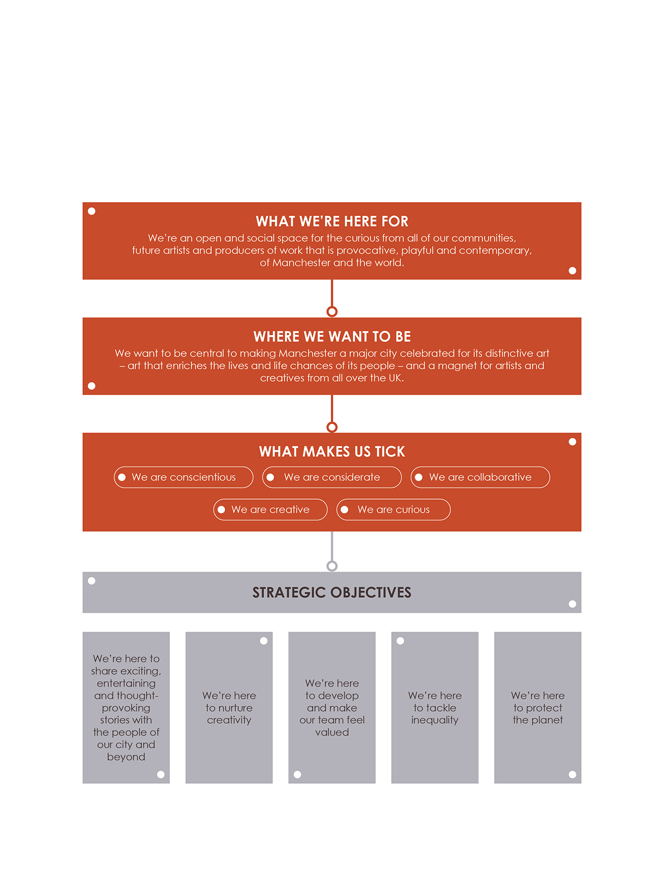
OUR VISION
& MISSION

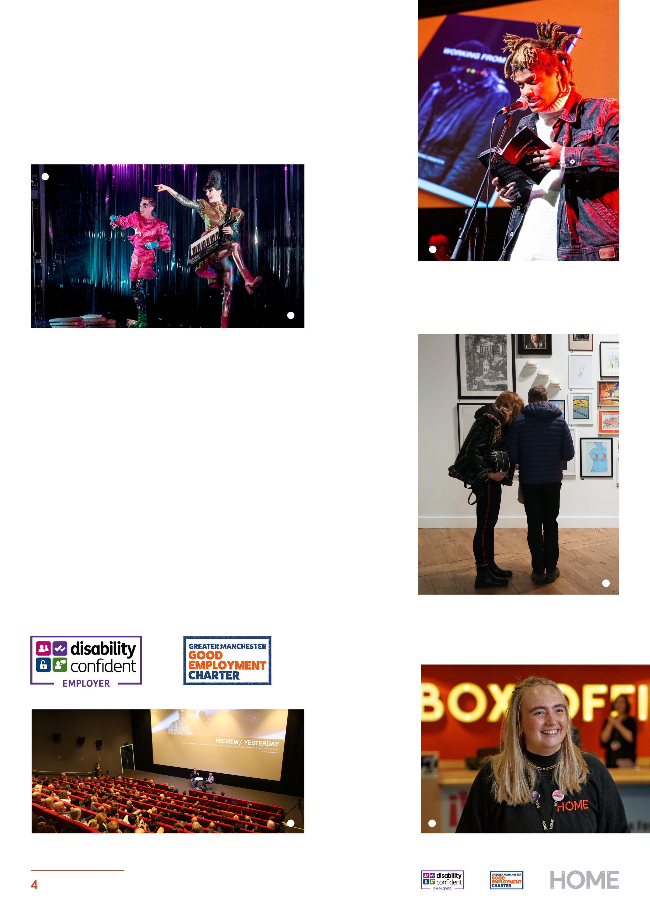

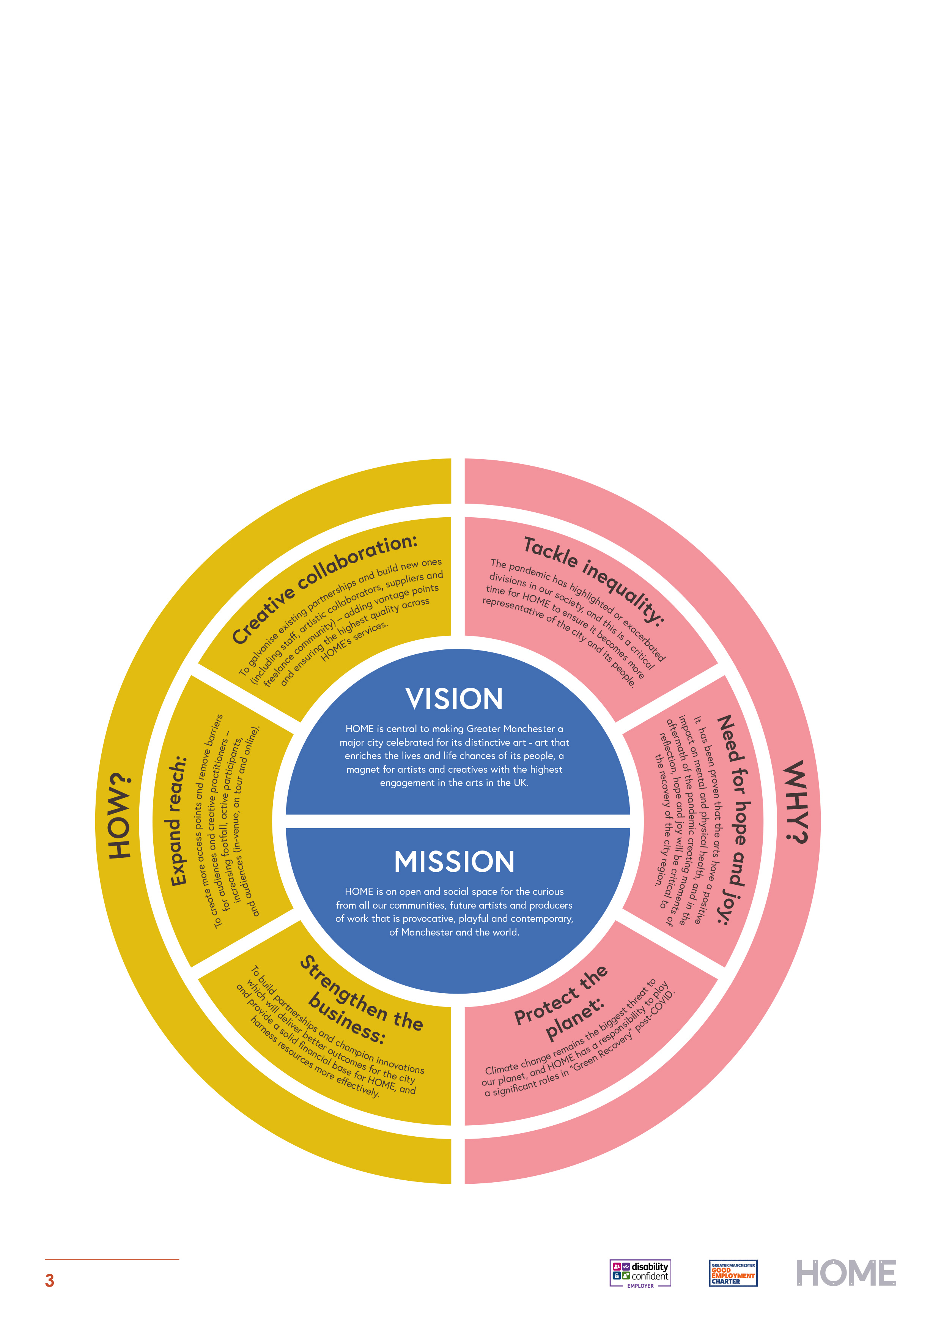

Equality at HOME

We want our workforce to reflect the diverse communities of Greater Manchester and we welcome candidates from all backgrounds. We actively encourage and support applications from groups who are currently underrepresented across the arts sector, including;
- Members of the Global Majority
- Individuals from lower socio-economic backgrounds
- Deaf, disabled and/or neurodiverse applicants
- People from the LQBTQIA+ community

HOME is a Disability Confident Employer, and a Supporter of the Greater Manchester Good Employment Charter.



KEY INFORMATION

Salary | National Living Wage  £12.60 Per Hour
Contract | Fixed Term, 22 Weeks (5.5 Months)
Hours of work | 233 hours total over 22 weeks. Working hours dictated by project delivery and are outlined below.  Exact hours of work as required by the job. Overtime payments will not be made, however, time off in lieu (T.O.I.L), with the line manager’s agreement, will be available to cover any additional hours worked.
Holidays | 25 days pro rata
Pension | GMAC Ltd operates a company pension scheme with a 3% company contribution, that is available to all staff
Other benefits | Discounted cinema tickets  Discounted theatre tickets  Employee Assistance Programme  Discounts in the HOME shop and restaurant
Probationary period | 2 weeks
Notice period | 2 weeks


JOB DESCRIPTION
Purpose
As the BFI Film Academy Intern, you would become part of the Creative Development team working closely with the Creative Development Film and Digital Practitioner, the BFI Film Academy Lead Producer and the BFI Producer Assistant and Content Coordinator, working together to ensure that the 2024 BFI Film Academy at HOME is the best yet.

The BFI Film Academy will welcome 20 young people aged 16-19 to explore what it takes to establish a career in film through industry talks, creative workshops and the creation of a short film that will be screened at HOME. Your aim is to support the facilitation, organisation and delivery of this year’s content.

Main duties
- Work closely with the Creative Engagement Practitioner of Film and Digital and the BFI Film Academy Lead Producer to complete tasks set by them to a high standard
- Completing administrative tasks such as responding to emails, managing the completion of consent forms, cash requisitions, managing contracts, inputting into the budget, ordering resources, printing materials, room bookings
- Support the recruitment process for applicants including communicating with candidates, shortlisting applicants in line with the criteria, and supporting successful candidates through the enrolment process
- Supporting the Arts Award Coordinator in delivering the online sessions as a representative of HOME. Aiming to promote engagement with cohorts from across the BFI North West Consortium.
- Working closely with young people to promote engagement ensuring that participants' welfare remains central to the project. Capturing photographs throughout the course to use as part of the Arts Award portfolio.
More Details
- HOME requests flexibility for the individual to work occasional evenings and weekends (with advance notice) in line with the delivery of these events (HOME is mindful of any responsibilities outside of work and will aim to provide
3 weeks’ notice where possible to allow provisions to be made)
- HOME will provide safeguarding training to ensure you are equipped with the information required to work in these environments safely.
- HOME will complete a DBS check as part of your enrolment once appointed.


PERSON SPECIFICATION

Essential skills & experience
 | Essential | Desirable
Attitude | Willingness to learn and ask questions.  Keen interest in Film and working with young people.  Creative problem-solving and initiative to find ways to support the project. | A passion for inclusion as the project aims to reach those underrepresented in film.
Experience  personal, educational or employment experience are all valid | Working towards a goal as part of a team.  Experience of participating in the Young Film Collective or BFI Film Academy as a participant.  Technically literate to be able to manage online sessions. | Delivering online sessions (Via Zoom/ Team)
Practical Skills | Previous use of Windows applications: Word, Excel, PowerPoint.  Proficient reading and writing skills (proofreading will be provided and this position is suitable for those who may have challenges with spelling or grammar)  Familiarity with Outlook (or other email and calendar scheduling apps) | Use of a DSL camera to help capture content throughout the sessions towards the Arts Award
Current Work Schedule (Subject to amendments)

September 2025
Wednesday 3rd September 10:00 – 16:00 (Induction)

Wednesday 10th September 10:00 – 16:00 (Admin)

Wednesday 17th 10:00 – 16:00 (Admin)

Monday 22nd 10:00 – 16:00 (Admin)
Wednesday 24th 10:00 – 16:00 (Admin)

October 2025
Wednesday 1st 10:00 – 16:00 (Admin)

Monday - 5th – 10:00 – 16:00 (Admin)
Wednesday 8th 10:00 – 16:00 (Admin)

Wednesday 15th 14:00 – 20:00 (Admin & BFI Academy Intro Session)

Wednesday 22nd 10:00 – 16:00 (Admin)
Saturday 25th 09:00 – 17:00 (Consortium Trip)

Tuesday 28th 10:00 – 16:00 (Session)
Thursday 30th 10:00 – 16:00 (Session)

November 2025
Wednesday 5th – 10:00 – 18:00 (Admin)
Saturday 8th – 10:00 – 16:00 (Session)

Wednesday 12th 13:00 – 19:00 (Admin & Evening Online Session)
Saturday 15th – 09:00 – 17:00 (Shoot Day)
Sunday 16th – 09:00 – 17:00 (Shoot Day)

Wednesday 19th – 10:00 – 18:00 (Admin)
Saturday 22nd – 09:00 – 17:00 (Shoot Day)
Sunday 23rd – 09:00 – 17:00 (Shoot Day)

Wednesday 26th – 14:00 – 19:00 (Admin & Evening Online Session)
Saturday 29th – 10:00 – 15:00 (Session)

December 2025
Saturday 6th – 10:30 – 15:30 (Session)
Wednesday 10th – 16:30 – 18:30 (Evening Online Session)

January 2026
Saturday 10th – 09:00 – 16:00 (Session)

Saturday 17th – 09:00 – 16:00 (Session)

Saturday 24th – 09:00 – 16:00 (Session)

Feb 2026
Wednesday 11th – 10:00 – 15:00 (Admin)
Saturday 14th – 14:00 – 18:00 (BFI Celebration Event)

Wednesday 18th – 10:00 – 15:00 (Admin)

Wednesday 25th – 10:00 – 15:00 (Admin)

March 2026
Wednesday 4th - – 10:00 – 16:00 (Admin)

Monday 9th - – 10:00 – 16:00 (Admin)
Wednesday 11th – 10:00 – 14:00 (Final Day)

HOW TO APPLY

The deadline for applications is 4th August 2025 at 10am.

Email WBTraining@homemcr.org with your:
- CV
- Cover Letter
- And please complete this online form (Don’t forget to click submit) Equal Opportunities Form

You can submit your cover letter as a video or audio if you prefer.

In the cover letter please ensure you provide examples of how you meet the criteria listed under the person specification for this role. This should be no longer than 1 A4 page (Size 12 font) or a video/ audio response no longer than 5 minutes in total.

Interviews will take place in person on w/c 11th August 2025
Interview questions will be shared in advance to allow you time to prepare.

Offers will be made the following week.

The start date for the position will be from the week commencing the 1st of September 2025.

This will allow time for us to collect references and complete a DBS check.

Due to our team capacity, we will not be able to inform or provide feedback for applicants not selected for interview.

Thank you for your interest in this post.

