Schools & Colleges Programme Producer

Application Pack

GMAC is funded by

SCHOOLS & COLLEGES PROGRAMME PRODUCER

HOME is Greater Manchester’s international contemporary cross art form production and presentation centre that has an acute focus on bringing curious multi-generational and diverse audiences together with great artists, art works and important ideas about the world we live in. HOME is playful and fun but not afraid of big ideas and issues. HOME is a people place, not a cultural palace. Every member of Team HOME wants to make a difference to our city region through great art work and experiences.

HOME was created from the merger of two much loved Greater Manchester institutions, Cornerhouse and the Library Theatre Company. Our new £25m building, funded by Manchester City Council, ACE and numerous donors, trusts and foundations, opened in May 2015 and has been a huge success with:
- over 1million visits in year 1
- making a financial surplus
- achieving very strong audience approval
- local, national and international artistic recognition and plaudits
- establishing a new high quality artistic brand
- creating a ‘must visit’ cultural destination in Manchester

HOME includes a 500 seat theatre, 160 seat flexible theatre space, 500m² gallery space, 5 cinema screens, education spaces, digital production and broadcast facilities, a café bar, a restaurant, offices and other ancillary spaces consistent with a production centre and a making place – intimately concerned with providing new opportunities for artists and audiences to create work differently. For more information see appendix 1 and 2 and visit our HOME website here.

HOME is a National Portfolio Organisation receiving 3-year funding from Arts Council England. As part of the move, HOME entered into a long term funding arrangement with Manchester City Council. Additional public funding is also received from the British Film Institute and Association of Greater Manchester Authorities.

HOME is a registered charity. Our turnover is £6.5mill per year. HOME generates income through ticket sales, fundraising and commercial trading. We run a very successful café and 3 bars, an onsite shop, an events and conferencing business and a publication and book distribution company – Cornerhouse Publications. We employ around 90 permanent staff complimented by a large number of casual staff and volunteers.

Our Ideal Candidate

This is the perfect opportunity to work across theatre, film and art with diverse groups of people from across Greater Manchester and beyond.

The Schools & Colleges Programme Producer is vital to ensuring HOME is an organisation that inspires young people, schools and colleges to engage in and learn through the arts, whilst developing confidence, skills and knowledge relevant to their independent learning.

This post holder will report to the Head of Engagement and will work closely with all Artistic teams, Front of House teams and with other Engagement staff to deliver our unique Schools & Colleges strand.

You will be part of an exciting forward-looking organisation working with a wide range of artists, partners, audiences and stakeholders. Our team is enthusiastic, motivated and engaged so expect to be challenged! If you can share our ambition and have the skills, knowledge and experience to do the job, this is a great and unique opportunity.

You will be a great people person with a passion for the arts and a highly organised and self-motivated character. You will have a track record of working with schools to programme and organise creative projects and programmes.

Liaising with various people will be second nature to you, from artists and programmers, to teachers and pupils. Managing the expectations and needs of these people will be something you excel at.

You will be an excellent communicator with a high level of admin skills and will have the skills and experience to cater information sharing as appropriate for various people with different learning styles.

Application Procedure

Please complete the HOME application form telling us how you meet the Person Specification for this role and return it with the completed Equal Opportunities form.

Closing date for applications: 10am on Mon 15 May 2017.
Interviews will take place on Mon 22 May 2017.

Please email a PDF of your application to marisa.draper@homemcr.org

If you have not heard from us by Thu 18 May, please assume that we will not be taking your application any further.
Unfortunately we cannot provide individual feedback on applications.

HOME strives to be an equality of opportunity employer

Job Description for Schools & Colleges Programme Producer

Purpose
To be responsible for the programming, organisation, administration and delivery of HOME’s Schools & Colleges programme strand which aims to raise educational attainment in arts and culture by working in partnership with schools, colleges and learning providers to:
- Provide access points for a diverse range of young people to get involved in the arts and with HOME.
- Inspire creativity in the classroom by supporting the development of teaching and learning in art, film, theatre and digital technologies.
- Identify, develop and promote talent amongst pupils and students.

Responsible to: Head of Engagement

Responsible for: Programming, organisation, administration and delivery of HOME’s Schools & Colleges strand.

Main Duties

1. To programme, plan, organise and deliver HOME’s School & College activity, inclusive of tours and talks, day-long study sessions and short-term in-school projects.

2. To ensure that the Schools & Colleges programme links to HOME’s core programme by working closely with Head of Engagement, Programme Managers and Producers across the organisation.

3. To contract and oversee a team of freelance artists, facilitators and Project Assistants and to supervise junior staff when necessary.

4. To make and maintain partnerships and relationships with formal education institutions in Greater Manchester.

5. To maintain a working knowledge of the requirements of the National Curriculum, GCSE, A Level and equivalent qualifications, and to keep up to speed with developments in education.

6. To work with Communications staff to ensure suitable publicity and other promotional material is produced and distributed to promote the Schools & Colleges strand activity.

7. To write copy and oversee the provision of appropriate documentation for the Schools & Colleges strand, including an annual programme of events.

8. To co-manage the Schools & Colleges budget in liaison with the Head of Engagement, and to assist in raising additional financial support for special projects and events when necessary.

9. To evaluate events and prepare material for the written reports for HOME's Board and funders.

10. To ensure that all activity is planned and delivered according to HOME’s Health and Safety, Child Protection and Safeguarding policies and that all people who need to be DBS checked as part of our work are vetted before undertaking activity with us.

11. To undertake any duties relevant to the post as required by the Chief Executive.

PERSON SPECIFICATION FOR SCHOOLS & COLLEGES PROGRAMME PRODUCER

 | Essential | Desirable
QUALIFICATIONS AND TRAINING | Educated to degree level or with comparable life experience | Teaching or youth education training
SPECIALIST KNOWLEDGE | Knowledge and understanding of contemporary theatre, visual arts and film culture.  Up to date knowledge of formal education and informal learning for 14 - 19 year olds.  Up to date knowledge of legalities and best practice around safeguarding and child protection. | Familiar with cultural provision in Greater Manchester region  A second language.  Knowledge of national cutting edge cultural formal education programmes.
EXPERIENCE | Two or more years of experience in programming, planning, organising, promoting and coordinating events for school and college pupils.  Two or more years of experience of recruiting and briefing event and workshop facilitators e.g. artists, freelance facilitators, teachers, educators.  Managing budgets.  Research and evaluation of projects. | Working in an arts organisation  Using digital technologies in creative ways in formal education practice to enhance learning across the curriculum.  Public speaking.  Preparing and presenting reports.
PRACTICAL & INTELLECTUAL SKILLS | Ability to work on own initiative and prioritise and organise a varied workload.  Excellent time management and organisational skills.  Ability to work under pressure, remain calm and meet deadlines.  Excellent team working skills.  Excellent communications skills both written and verbal.  Flexible and imaginative approaches to communicating ideas and skills.  Ability to work with wide range of people.  Numerate.  Computer literate in word processing and use of spreadsheets and database programmes.  Skilled in the use of web and internet communications and research tools. | Advanced presentation skills.
DISPOSITION & ATTITUDE | A collaborative outlook to working across the organisation and with external partners.  Committed to creating great experiences and opportunities for diverse groups of people.  A friendly and open personality with the ability to communicate with a diverse range of people.  Ability to travel throughout Greater Manchester region.  Demonstrable understanding of and commitment to Equal Opportunities. | Creative approach to work and problem solving.
PERSONAL CIRCUMSTANCES | An informed interest in the type of work presented by HOME.  Understanding of, and commitment to customer service.  Able to work flexible hours with reasonable notice.  This post is based in Manchester.

Applicants should be willing to complete Enhanced Disclosure criminal records check through the Disclosure and Barring Service if selected for this post.

TERMS AND CONDITIONS OF SERVICE

SCHOOLS & COLLEGES PROGRAMME PRODUCER

GMAC Ltd has a Staff Manual that provides full details of all terms and conditions of employment as well as staff benefits. The following are the main terms of employment.

Salary Grade 3 (£23,000 pro rata)

Hours of work The post holder will work 20 hours per week (inclusive of lunch breaks) and mainly from Tuesday to Thursday with a degree of flexibility to accommodate projects taking place on different days.

Exact hours of work as required by demands of the post.
Overtime payments will not be made, however time off in lieu, with the agreement of the Head of Engagement, will be available to cover any additional hours worked.

Contract Period Nine months initially

Probationary period 2 months

Period of notice 1 month will apply to both employer and employee

Holidays 25 days p.a. plus statutory holidays

Appendix 1
Further Information About HOME

HOME Vision
HOME is central to making Greater Manchester a major city celebrated for its distinctive art, art that enriches the lives and life chances of its people, a magnet for artists and creatives with the highest engagement in the arts in the UK.

HOME Mission
HOME is an open and social space place for the curious from all our communities, future artists and producers of work that is provocative, playful and contemporary, of Manchester and the world.

HOME Values
- Creativity – bringing imagination, resourcefulness and innovation to our work
- Pioneering – leading the way, breaking new ground, being ahead of the curve, taking risks
- Collaborative – seeking out opportunities for sharing and partnership
- Engaged – with our city region and the wider world, with art and artists and with ideas and issues
- Open – welcoming and engaging with multiple voices, ideas and perspectives
- Rigorous – striving to do the best work, valuing quality.

Outcomes by 2022
By 2022 HOME will have achieved the following outcomes:
- HOME has a more diverse multi-generational audience that reflects the population of Manchester
- Our brand Is recognised in the UK for distinctive high quality diverse programming from outside the main stream engaging a broad range of audiences
- HOME has made a positive impact on the careers of emerging artists
- HOME makes a demonstrable positive social impact on Greater Manchester through our art and our responsible business model
- HOME has a financially and environmentally sustainable business model that enables artistic risk and growth
- Digital production and distribution is embedded into programming and our on-line audience will have doubled
- The workforce and governance of HOME is engaged, diverse and highly skilled

Programme Strands
Film - An extraordinary and independent programme and experience across five screens.
Theatre - is international, interdisciplinary, provocative, questioning, visual and poetic.
Visual Art - foregrounds artists' projects that work across its distinctive strengths - artist film, performance and participation.
Community & Young People - with and for the people of our city.
Digital & Creative Development – developing local talent.
Appendix 2
HOME’s Engagement Strategy

Our engagement activity is crucial to achieving the vision for HOME because it connects with an exceptionally diverse mix of people who see and shape our programme. Our mission and vision statements express this ambition:

This is HOME
We live to work with artists to produce questioning and ambitious artistic projects and involve audiences with new and extraordinary experiences in contemporary theatre, visual art and film.

HOME’s programme across all art forms is unique for it’s ability to tell stories that aren’t found elsewhere. Across productions, exhibitions, commissions and projects, it’s clear that HOME is where artists create the type of work that interrogates and illuminates our contemporary existence.

By ‘engagement’ we mean every activity that enables people to get closer to the programme, artists and art-forms, and to tell their own stories through their own artistic creations. HOME engagement is unlike anywhere else, with an integrated programme, which spans five distinct strands:

- Visual art
- Film
- Theatre
- Community and Young People
- Digital and Creative Development

The latter two strands: Community & Young People and Digital & Creative Development, are led and developed by HOME’s Head of Engagement. Both these strands work with the three art forms that make up the other strands of our work: Visual Arts, Film and Theatre. Often experimental, engagement also dwells at the point where these art forms meet.

Work-based training cuts across our activities with work experience, internships, apprenticeships and volunteering being offered across the organisation.

Our Model for Engagement

Community & Young People, which segments into:
a) Schools & Colleges
b) Young People aged 15-25 who engage with us in their own time
c) Communities based near HOME

Digital & Creative Development, which provides artists and audiences with a range of ways to get deeper into our programme and develop their own creativity:
a) General Creative Offer: talks, tours, courses, animating public spaces
b) Specialised Creative Offer: skills/talent development, showcases, networks
c) Research & Development: experimental, innovative making of new work

Work-based training cuts across our activities with work experience, internships, apprenticeships and volunteering being offered across the organisation.
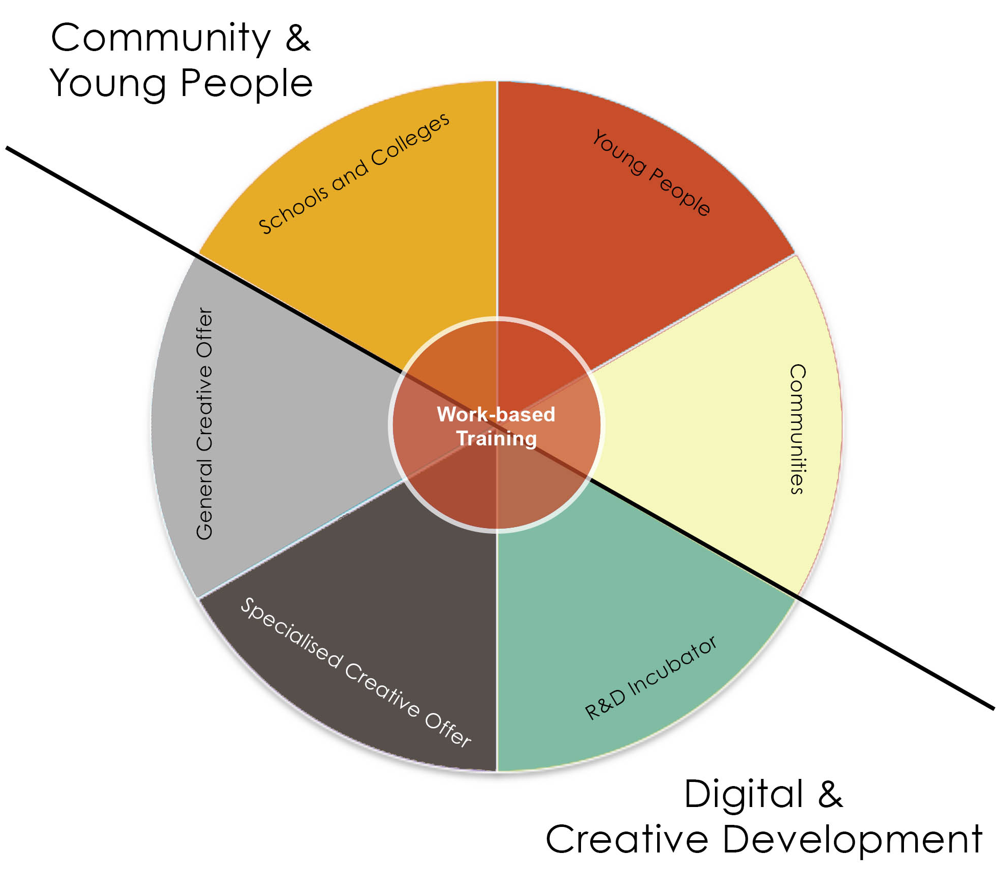

The Engagement Team Structure
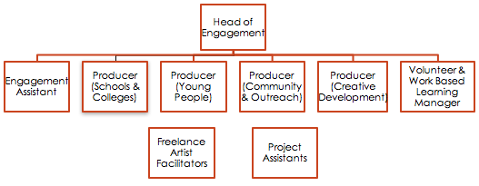
Schools & Colleges

The aim of our schools & colleges offer is to raise educational attainment in arts and culture.
We do this by working in partnership with schools, colleges and learning providers to:
- provide access points for a diverse range of young people to get involved with the arts and with HOME;
- inspire creativity in the classroom by supporting the development of teaching and learning in theatre, film, digital and visual arts;
- identify, develop and promote talent amongst pupils and students.

HOME’s schools and colleges programme works with the 3 main art forms at the venue to enrich students’ learning. It involves creative approaches to engaging students and will tie-in directly to topics covered in GCSEs and A Levels. It includes:

- Schools ticket deals to performances and screenings
Schools & colleges benefit from reduced rate tickets for theatre productions and film screenings.

- Tours, talks, workshops and occasional opportunities to meet and watch artists at work (long-term strand)
These are scheduled and bespoke events, that either involve a tour of the venue or that relate directly to the theatre, film and visual art programmes. They enable students to get a deeper understanding of our work and are organised on request.

- Study Sessions
These are mainly curriculum focussed around Film & Media and Modern Foreign Languages (French, Spanish, German, Arabic, Urdu).
Sessions involve GCSE and A Level study sessions (half or full days). Industry experts lead these sessions, using film as a basis to teach young people about specific topics or works that are relevant to the qualifications they are working towards. Study sessions include watching a feature length film, which is then dissected by the session leader and students.

- Short-term in-school projects.
Projects relate directly to the programme at HOME and are creative based. Some of these projects will be designed specifically for and in collaboration with special schools.

