Assistant Director CITY OF GLASS
Application Pack

GMAC is funded by
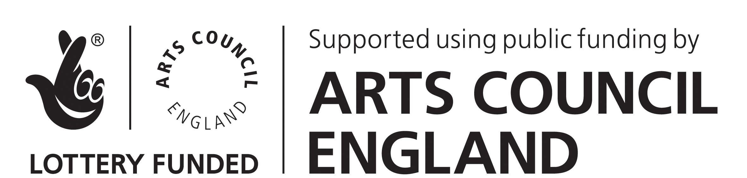

Job Title – Assistant Director – CITY OF GLASS
59 Productions, HOME and Lyric Hammersmith

The JMK Trust in partnership with HOME is offering an Assistant Director Bursary to a participant of the JMK & Direct North Directors’ Group. The bursary is an arts scholarship, funded by the Leverhulme Trust that will provide a learning and training opportunity for a talented emerging director, based in the North West of England area who has demonstrated a commitment to directing and a passion for theatre making. The recipient will become a Leverhulme Arts Scholar.

Our Ideal Candidate

We are looking for an Assistant Director to assist Director Leo Warner on 59 Productions, HOME and Lyric Hammersmith’s production of Paul Auster’s CITY OF GLASS, adapted for the stage by Duncan Macmillan. This bold, technically ground-breaking production, directed and designed by 59 Productions with a multiple award-winning creative team, uses stagecraft, projection, magic and illusion to immerse audiences in the kaleidoscopic world of this seminal American novel.

The bursary recipient will demonstrate a commitment to living and making theatre in the North West and will also be or become a participant of the JMK Direct North Directors’ Group and as part of the bursary will also be responsible for working with the JMK Artistic Coordinator, Direct North and HOME to support and facilitate the group until next year’s bursary recipient is chosen.

Experience of working with text and movement, working with child performers and touring will be beneficial, but not essential.

Application Procedure
Please send a CV and covering letter to Jennie.McCusker@homemcr.org.
Please detail:
- Why you are interested in working on this production of CITY OF GLASS
- How this assisting opportunity and involvement in the JMK Trust Directors’ group will contribute to your professional development
- Your relevant experience and what you can bring to the role
- Your commitment to living and making theatre in the North West
The deadline for applications is Monday 21 November 2016

Interviews will take place on Tuesday 6 December between 1pm to 4pm.

Unfortunately we cannot acknowledge receipt of applications. If you have not heard from us by Friday 2 December please assume that we will not be taking your application any further.

HOME strives to be an equality of opportunity employer. Thank you for your interest in this post.
If you have any questions please contact jo@jmktrust.org

Job Description for Assistant Director, CITY OF GLASS

Job title: Assistant Director, CITY OF GLASS

Responsible to: Leo Warner, Director of CITY OF GLASS

The JMK Trust in partnership with HOME is offering an Assistant Director Bursary to a participant of the JMK & Direct North Directors’ Group. The bursary is an arts scholarship, funded by the Leverhulme Trust that will provide a learning and training opportunity for a talented emerging director, based in the North West of England area who has demonstrated a commitment to directing and a passion for theatre making. The recipient will become a Leverhulme Arts Scholar.

Main Duties:
As Assistant Director, your duties would include:
- To observe and assist the Director in pre-production, rehearsals, technical rehearsals and previews at both venues.

- As agreed with the Director, to carry out any research that will inform and benefit the production.

- To assist with the local casting of child actors in Manchester and London.

- To attend and have input into creative and production meetings.

- To assist the producers and venues in documenting the rehearsal process for the purposes of marketing, archiving and evaluating the project through blogs, social media and other forms as agreed.

- To attend and participate in post-show discussions as reasonably required by the producers.

- To input into engagement and educational activities or events by mutual agreement with the producers and venues.

- To attend, note and maintain the production in performance, supporting the adult and child acting company as agreed with the Director, Company Stage Manager and chaperones.

- Any further duties as required by the Director and producers.

TERMS AND CONDITIONS OF SERVICE

Assistant Director – City of Glass

Dates: The Assistant Director will need to be available on an exclusive basis for:
London rehearsals from 23rd January – 22nd February 2017

HOME Manchester opening from 24th February – 9th March 2017
Technical rehearsals from 24th February 2017
Previews from 4th March 2017
Press night: 9th March 2017
Final performance: 18th March 2017

Lyric Hammersmith opening from 15th – 25th April 2017
Technical rehearsals from 15th April 2017
Previews from 20th April 2017
Press night: 25th April 2017

Fee: £2,350 inclusive of all expenses. During London rehearsals and performances an allowance (in line with UK Theatre minimum rates) will be paid, and standard class return rail travel costs (or equivalent) to and from the Assistant Director’s home address will be reimbursed.

Hours of work: Monday to Saturday,
10am to 6pm with evening work to be confirmed.

Appendix 1
HOME Vision
To be an international production and exhibition centre of outstanding provocative contemporary theatre, visual art and film and an axis of experimentation at the point where they meet. To be a HOME for both artists and audiences, with a strong reputation for use of digital media communication and distribution, developing talent, audience engagement, and working creatively with communities.

HOME Mission
We live to work with artists to define a new form of art centre by producing and presenting questioning ambitious artistic projects in and of Manchester but with a distinctive international outlook that grows and involves audiences through new remarkable experiences and diverse stories

Strategic Aims
- To position HOME as a major national and international centre with a body of work and reputation for great/distinctive/diverse contemporary work
- To have developed cross artform practice that attracts new partnerships and investment
- To have created a sustainable business model for HOME that enables artistic risk and growth
- To have built a new audience for HOME and re-positioned programme and offer
- To have established an organisational culture for HOME that supports the artistic ambition

Over the three-year journey to establish HOME the organisational trajectory will be one of progressive growth:
- 2015-16 will give HOME a Safe Landing as the doors are opened and the organisation explores the rhythm of the new building, builds its relationship with local and regional audiences and develops Team HOME.
- 2016-17 will see Team HOME Turn Up The Volume on the programme and engagement with audiences having got a better understanding of the potential of HOME’s new spaces and new partnerships have been established with co-producers and co-commissioners
- 2017-18 Team HOME will move up another gear and to Almost Full Volume making the most of the having re-defined the organisation’s artistic place, created a new track record and developed strong national and international links

Key success measures
HOME will know it has been successful if by March 2018 the organisation:
- Is perceived by its stakeholders as a major national and international centre with a body of work and reputation for great/distinctive/diverse contemporary work
- Has developed cross artform practice and attracted new partnerships and investment to that work
- Has a sustainable business model that enables artistic risk, growth and social impact
- Has increased and diversified the audience and re-positioned programme and offer within Greater Manchester and the North West
- Has an organisational culture for that supports the artistic and business ambition, high performance and diversity

Programme
HOME Film - An extraordinary and independent programme and experience across five screens
HOME Theatre - is international, interdisciplinary, provocative, questioning, visual and poetic.
HOME Visual Art - foregrounds artists' projects that work across its distinctive strengths - artist film, performance and participation
HOME Community & Young People - with and for the people of our city
HOME digital & creative - to help to develop the creative industries

