Development Manager
Application Pack

GMAC is funded by

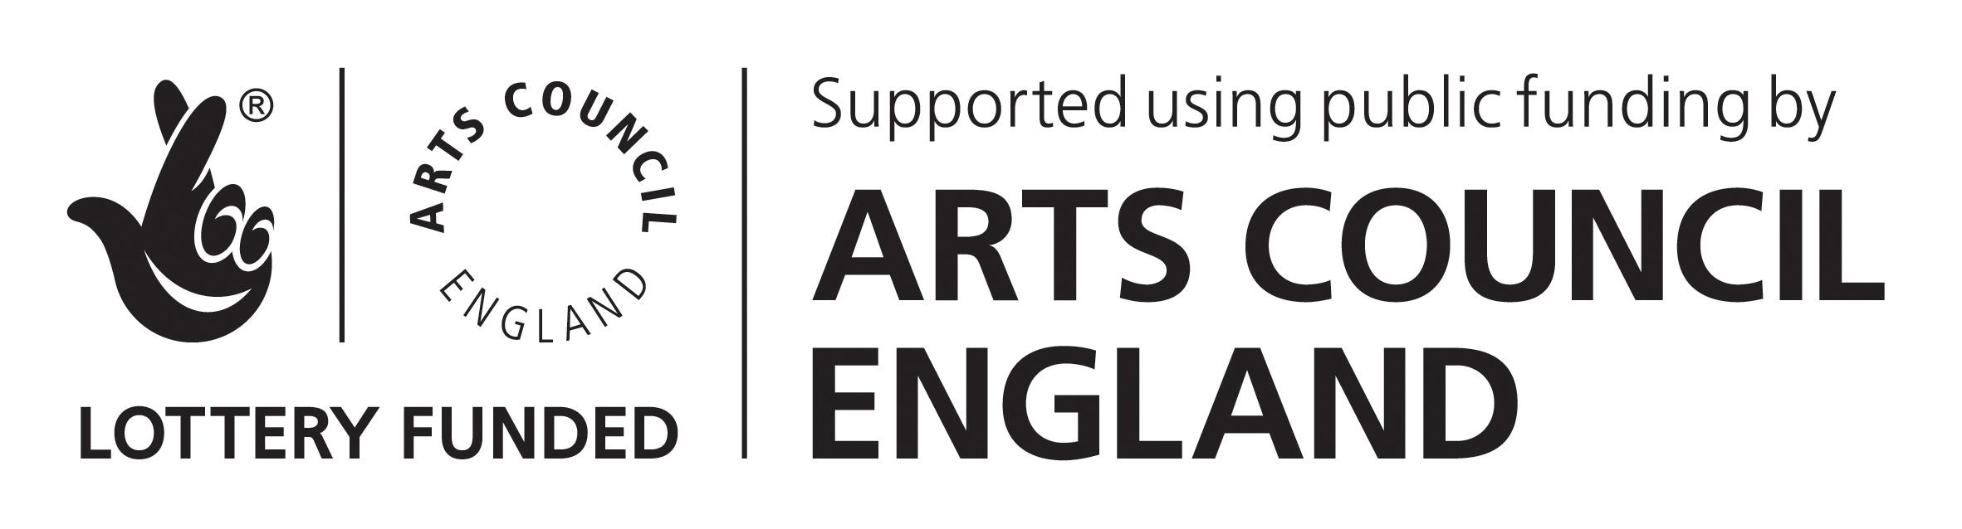

Job Description

JOB TITLE: Development Manager
Responsible to: Development Director
Responsible for: Development Officer
Team: Development

Full-time permanent contract (but part time or job share would be considered)

About the job
Every year, the Development Team generates over £850,000 income to support HOME, inspiring donors to support a range of activities including our high-quality public programme, artist development programmes, widening access to the arts and supporting Manchester’s next generation of creative talent. In summer 2022, we will break ground on HOME Arches, an exciting new talent development hub for Manchester’s artistic community situated in the railway arches between HOME and Whitworth Street West. This has created an exciting new driver for donors and will be a key part of the team’s focus over the next 2 years.
We are now seeking a driven, organised and creative individual to join our team and play a vital role in reaching our targets, expanding our donor base, and embedding fundraising within the organisation. You would take the lead of building a pipeline of potential supporters, create high impact proposals, deliver pitches face to face with donors, and build long-term meaningful relationships with supporters, funders and sponsors.
You will have excellent relationship building skills and experience securing income from at least one of the following: individuals, grant-makers or companies, or strong transferable skills. You will be an excellent communicator with the ability to forge meaningful relationships with a wide range of people, with the ability to communicate clearly and persuasively.
This is a great opportunity for a motivated and imaginative fundraiser to make a real impact and join a respected and successful fundraising team at a pivotal and exciting time.

Main Duties and responsibilities:

Individuals, companies or charitable trusts

- Create and deliver plans to engage potential supporters that ensure long-term engagement and support, with particular focus on building long-term unrestricted income;
- Identify potential new and repeat supporters through independent research and conversations with Trustees and advocates;
- Manage a portfolio of existing supporter relationships, ensuring the highest quality of engagement for donors, and to identify opportunities for renewal or increased support;
- Ensure that all funding and sponsorship reporting requirements are met in a timely and professional manner;
- Create engaging and effective communications (proposals, campaigns, applications, pitches etc)
- Carry out in-depth prospect research to support approaches; gather data on HOME’s achievements, impact and output to support bids and proposals;
- Identify and research new fundraising opportunities for HOME both regionally and nationally; collaborate with other HOME departments to identify funding needs and opportunities;
- Work closely with the Development Director to ensure a consistent and well-presented message on financial need and opportunities for support;
- Work closely with the Development Director and Development Manager in the planning and delivery of the capital campaign for HOME Arches, and take responsibility for the public campaign;
- Support the servicing of public sector partners where required (Manchester City Council, GMCA, Arts Council England)
Management and process
- To line manage the Development Officer, carrying out regular 1-2-1’s
- To represent the Development team at regular meetings with HOME’s wider staff team (including programming, creative development, artist development)
- Contribute to fortnightly prospect management meetings with the Development team
- Maintain excellent records relating to donor relationships and prepare information for internal reports including board reports as required
Other Duties and Responsibilities
- To be an advocate and ambassador for HOME
- Keep up to date with developments in fundraising, particularly regulatory requirements, and work with the Development Director to ensure best practice is implemented across the Development Team’s work
- Adhere to all HOME policies, in particular those around diversity, environmental sustainability, and access
- Work evenings and weekends as appropriate
- Undertake national and international travel as required.
This is not an exhaustive list of duties and HOME’s management may, at any time, allocate other duties which are of a similar nature or level.

PERSON SPECIFICATION

Development Manager

 | ESSENTIAL | DESIRABLE
Experience | Proven ability to build, manage and develop effective relationships. This includes the ability to successfully negotiate with others to achieve desired outcomes  A demonstrable track record of success in securing five-figure gifts or contracts (including planning, securing and stewardship), or clear transferable skills  Proven ability to deliver income against agreed targets | Experience of fundraising in the cultural, arts or heritage sector  Experience of fundraising from individual major donors  Experience of capital fundraising
Skills and knowledge | Knowledge of the fundraising marketplace and current trends across the sector  Excellent interpersonal skills, with the ability to build rapport, and influence and persuade  Strong written communication skills, with the ability to write clearly and persuasively  Excellent organisational skills with the ability to plan as a team, whilst also working independently to deadline  Ability to record, interpret, analyse and present financial data clearly and accurately  Robust IT skills and experience working with databases | Commitment to, and interest in, the arts  Understanding of VAT and Gift Aid  Understanding of GDPR policies and procedures  Experience working with Spectrix
Qualification |  | Fundraising qualification
Other requirements | Ability to understand and communicate HOME’s work and mission  Confident, diplomatic with a clear sense of integrity  Flexibility and willingness to work evening and weekends as required
Applicant information

Deadline for applications: Monday 25 July 2022
Interviews will take place on Monday 1 August 2022

At HOME we welcome applications from everyone.
HOME strives to present a vibrant, diverse programme that is reflective of the city that we live in. We believe that this can only truly be achieved if the workforce at HOME encompasses a broad range of beliefs and vantage points. We particularly welcome applications from people from an ethnically diverse backgrounds or those who are Deaf or disabled, as they are currently under-represented in our workforce. If you wish to discuss reasonable adjustments for this role, please indicate this on your application form and we will be in touch with you.

Outline of Terms and Conditions

TITLE OF POST: Development Manager
HOURS: GMAC Ltd has a standard working week of 40 hours inclusive of meal breaks.
This is a full time post, but applications for part-time working or job sharing would be considered
Exact hours of work as required by demands of the post.
Overtime payments will not be made, however time off in lieu, with the agreement of the Development Director, will be available to cover any additional hours worked.
SALARY: £30k-£33.5k (dependent on experience)
ANNUAL LEAVE: 25 days p.a. plus statutory holidays, increasing with length of service thereafter.
PROBATIONARY PERIOD: 3 months.
NOTICE PERIOD: 1 month during probationary period, 3 months thereafter.
PENSION: HOME runs a workplace pension scheme.
OTHER BENEFITS INCLUDE:
- Free tickets for theatre and cinema
- Discounts on food and drink at HOME’s bar and restaurant
- Travel schemes including cycle to work
- Flexible working
- Family friendly and female friendly policies

