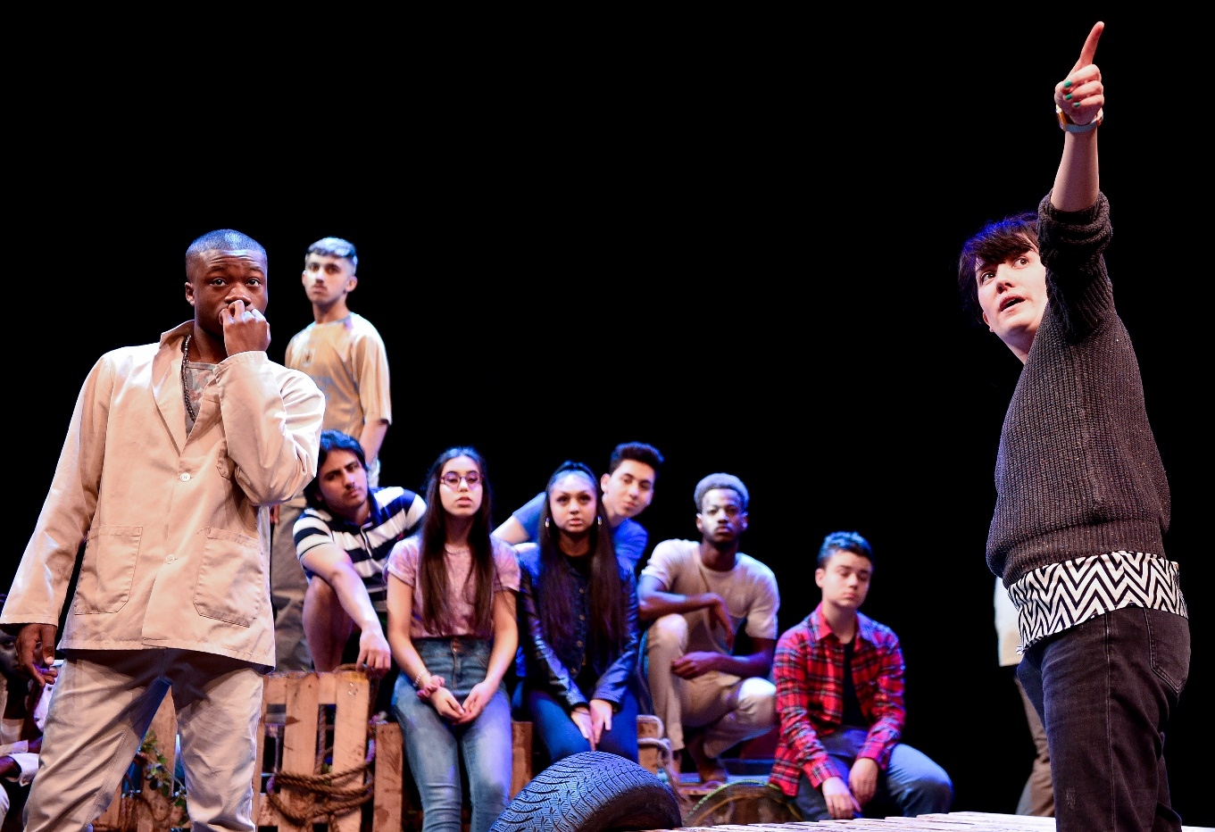

HOME’s Young Creative’s

Theatre Production (working title)

Calling all Young Greater Manchester Playwrights!

Are you aged 18-21?

Interested in writing your own play?

We are on the lookout for 5 young writers to create the script for a brand-new play, which our Young Company performers will take to the stage in August 2022

Overview of the project
HOME’s Young Company will be taking to the stage this summer with a brand-new play written by Young Writers from Greater Manchester.
Young Writers will work as a team to create a 30–40-minute piece of theatre. Working to a brief set by the Creative Team, you will have support from a Creative Writing Practitioner across five sessions.

Please see the dates and times in the table below.
Date | Time | Workshop | Venue
Sunday 12th June 2022 | 11am – 4pm | Getting Started | The Event Space, 2nd Floor. HOME
Wednesday 15th June 2022 | 6pm- 8pm | Building a draft | Zoom
Sunday 26th June 2022 | 11am – 4pm | Development | The Event Space, 2nd Floor at HOME
Tuesday 5th July 2022 | 6pm-8pm | Finalising Drafts | Zoom
Sunday 10th July 2022 | 11am - 4pm | Submission of the draft | The Event Space, 2nd Floor at HOME

Additional sessions can be organised to support the writing process.
The final draft will need to be submitted by 12pm on Wednesday 27th July 2022

Application Form

First Name:………………………. Surname:…………………………

Date of Birth:…………………. Age:……………………

Address:………………………………………………………………………………………
…………………………………………………………………………………………………
……………………………………….Postcode:…………………………………………

Application Questions
Please complete the questions below.
You can send your responses in any format you want, whether that be a video clip / voice note or written in the boxes below.
The deadline for applications is 5pm on Friday 20th May 2022
Please send your application to our Creative Writing Facilitator: Tiffany.Bowman@homemcr.org
The panel will consider these things when reviewing your application:
- Your level of enthusiasm for the project.
- Strength of your creativity, ideas and concepts.
- Originality and strength of your unique writing style/voice.
- We are not precious about spelling and grammar.

In your own words, please tell us why you are applying to be a part of the Young Writers team for this production. Please feel free to continue to a separate page if needed.

In the box below, please provide a short story. This can be any form you wish, such as a poem or script. Please feel free to continue to a separate page if needed.

Please use the box below to tell us something you’re passionate about, I.e. Poetry, Music, Theatre...etc. Please feel free to continue to a separate page if needed.

