Assistant Director On Corporation Street
Application Pack



GMAC is funded by
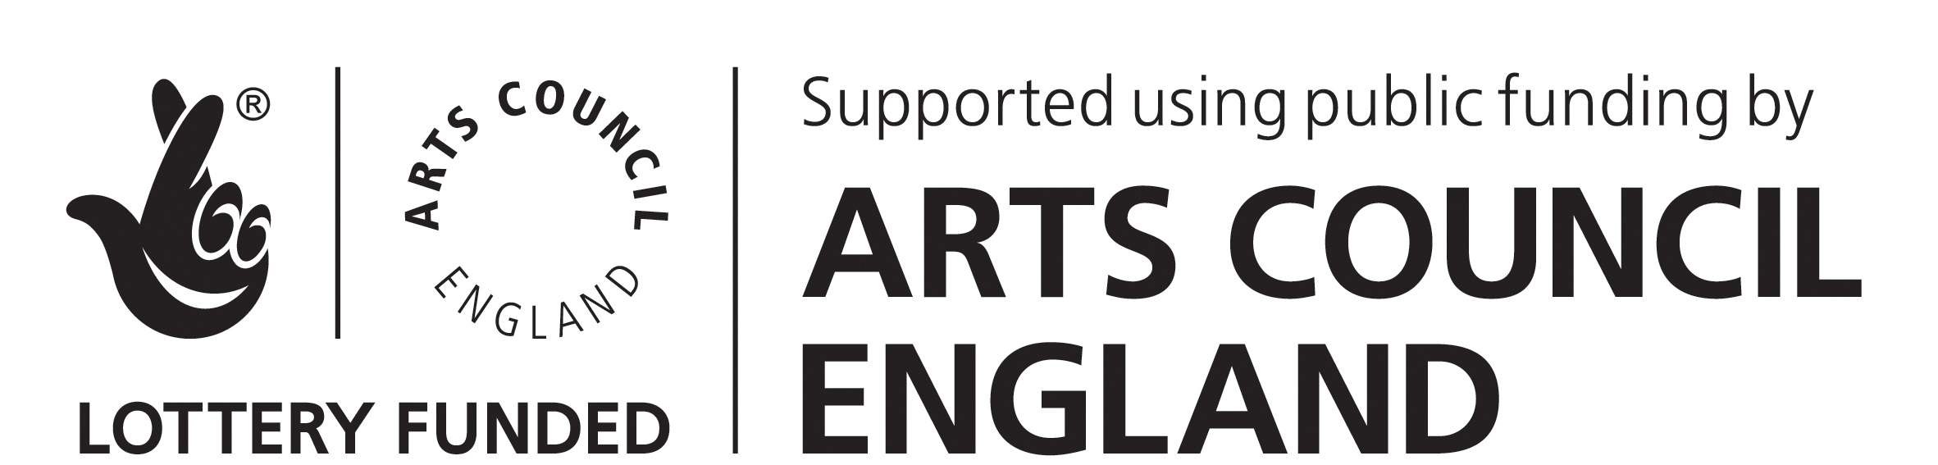



Job Title – Assistant Director – On Corporation Street
The JMK Trust in partnership with HOME is offering an Assistant Director Bursary to a participant of the JMK & Direct North Directors’ Group. The bursary is an arts scholarship, funded by the Leverhulme Trust that will provide a learning and training opportunity for a talented emerging director, based in the North West of England area who has demonstrated a commitment to directing and a passion for theatre making. The recipient will become a Leverhulme Arts Scholar.

Our Ideal Candidate
We are looking for an assistant director for ANU productions and HOME’S new production On Corporation Street. Following the sold-out Angel Meadow in 2014, HOME and ANU join forces again for another exhilarating and intimate experience. The year 2016 marks the twentieth anniversary of the bombing of Manchester by the provisional IRA. The bomb, the largest ever detonated in mainland Britain, devastated the city centre, and injured 212 people. On Corporation Street responds to this seismic event, a pivotal moment that transformed the shape of the city, and ANU will occupy HOME with a series of fearless and personal encounters.
The bursary recipient will demonstrate a commitment to living and making theatre in the North West and will also be or become a participant of the JMK Direct North Directors’ Group and as part of the bursary will also be responsible for working with the JMK Artistic Coordinator, Direct North and HOME to support and facilitate the group until next year’s bursary recipient is chosen.

Application Procedure
Please send a CV and covering letter to Jennie.McCusker@homemcr.org.
Please detail:
- Why you are interested in working with ANU Productions on this production of On Corporation Street.
- How this assisting opportunity and involvement in the JMK Trust Directors’ group will contribute to your professional development
- Your relevant experience and what you can bring to the role
- Your commitment to living and making theatre in the North West
The deadline for applications is Monday 22 February 2016
Interviews will take place on either 2nd or 3rd March between 7pm-9pm

Unfortunately we cannot acknowledge receipt of applications. If you have not heard from us by Friday 26 February please assume that we will not be taking your application any further.
HOME strives to be an equality of opportunity employer. Thank you for your interest in this post.



Job Description for Assistant Director, On Corporation Street

Job title: Assistant Director, On Corporation Street

Responsible to: Artistic Director’s ANU productions

The JMK Trust in partnership with HOME is offering an Assistant Director Bursary to a participant of the JMK & Direct North Directors’ Group. The bursary is an arts scholarship, funded by the Leverhulme Trust that will provide a learning and training opportunity for a talented emerging director, based in the North West of England area who has demonstrated a commitment to directing and a passion for theatre making. The recipient will become a Leverhulme Arts Scholar.

Main Duties:

As Assistant Director, your duties would include:
- To provide general assistance to the Director.
- As agreed with the Director, to carry out any research that will inform and benefit the production.
- To observe rehearsals and have input in discussions and production meetings.
- To assist the company in documenting the rehearsal process for the purposes of marketing, archiving and evaluating the project through blogs, social media and other forms as agreed.
- To assist audience route planning through the building.
- To observe and assist the Director in the production week as required.
- To attend and participate in post-show discussions by mutual agreement with the Producer.
- To input into supporting engagement activities by mutual agreement with the Director and Head of Engagement.
- To support the company whilst the play is in performance as agreed with the Director and Stage Manager, including attending and noting the production.
- Any further duties as required by the Director and with the producer.

TERMS AND CONDITIONS OF SERVICE

Assistant Director – On Corporation Street

Dates: The assistant director will need to be available for:
Manchester Rehearsals from 23rd May 2016
First preview: 10th June 2016
Press: 15th June 2016
Closes: 25th June 2016

Fee: £2,250 inclusive of all expenses

Hours of work: Monday to Saturday, 10am to 6pm with some evenings and weekend work to be confirmed.

Appendix 1
HOME Vision
To be an international production and exhibition centre of outstanding provocative contemporary theatre, visual art and film and an axis of experimentation at the point where they meet. To be a HOME for both artists and audiences, with a strong reputation for use of digital media communication and distribution, developing talent, audience engagement, and working creatively with communities.

HOME Mission
We live to work with artists to define a new form of art centre by producing and presenting questioning ambitious artistic projects in and of Manchester but with a distinctive international outlook that grows and involves audiences through new remarkable experiences and diverse stories

Strategic Aims
- To position HOME as a major national and international centre with a body of work and reputation for great/distinctive/diverse contemporary work
- To have developed cross artform practice that attracts new partnerships and investment
- To have created a sustainable business model for HOME that enables artistic risk and growth
- To have built a new audience for HOME and re-positioned programme and offer
- To have established an organisational culture for HOME that supports the artistic ambition

Over the three-year journey to establish HOME the organisational trajectory will be one of progressive growth:
- 2015-16 will give HOME a Safe Landing as the doors are opened and the organisation explores the rhythm of the new building, builds its relationship with local and regional audiences and develops Team HOME.
- 2016-17 will see Team HOME Turn Up The Volume on the programme and engagement with audiences having got a better understanding of the potential of HOME’s new spaces and new partnerships have been established with co-producers and co-commissioners
- 2017-18 Team HOME will move up another gear and to Almost Full Volume making the most of the having re-defined the organisation’s artistic place, created a new track record and developed strong national and international links

Key success measures
HOME will know it has been successful if by March 2018 the organisation:
- Is perceived by its stakeholders as a major national and international centre with a body of work and reputation for great/distinctive/diverse contemporary work
- Has developed cross artform practice and attracted new partnerships and investment to that work
- Has a sustainable business model that enables artistic risk, growth and social impact
- Has increased and diversified the audience and re-positioned programme and offer within Greater Manchester and the North West
- Has an organisational culture for that supports the artistic and business ambition, high performance and diversity

Programme
HOME Film - An extraordinary and independent programme and experience across five screens
HOME Theatre - is international, interdisciplinary, provocative, questioning, visual and poetic.
HOME Visual Art - foregrounds artists' projects that work across its distinctive strengths - artist film, performance and participation
HOME Community & Young People - with and for the people of our city
HOME digital & creative - to help to develop the creative industries

