Greater Manchester Arts Centre Ltd.

PUSH Festival 2018
PUSH Festival Assistant Internship

Application Pack

GMAC is funded by

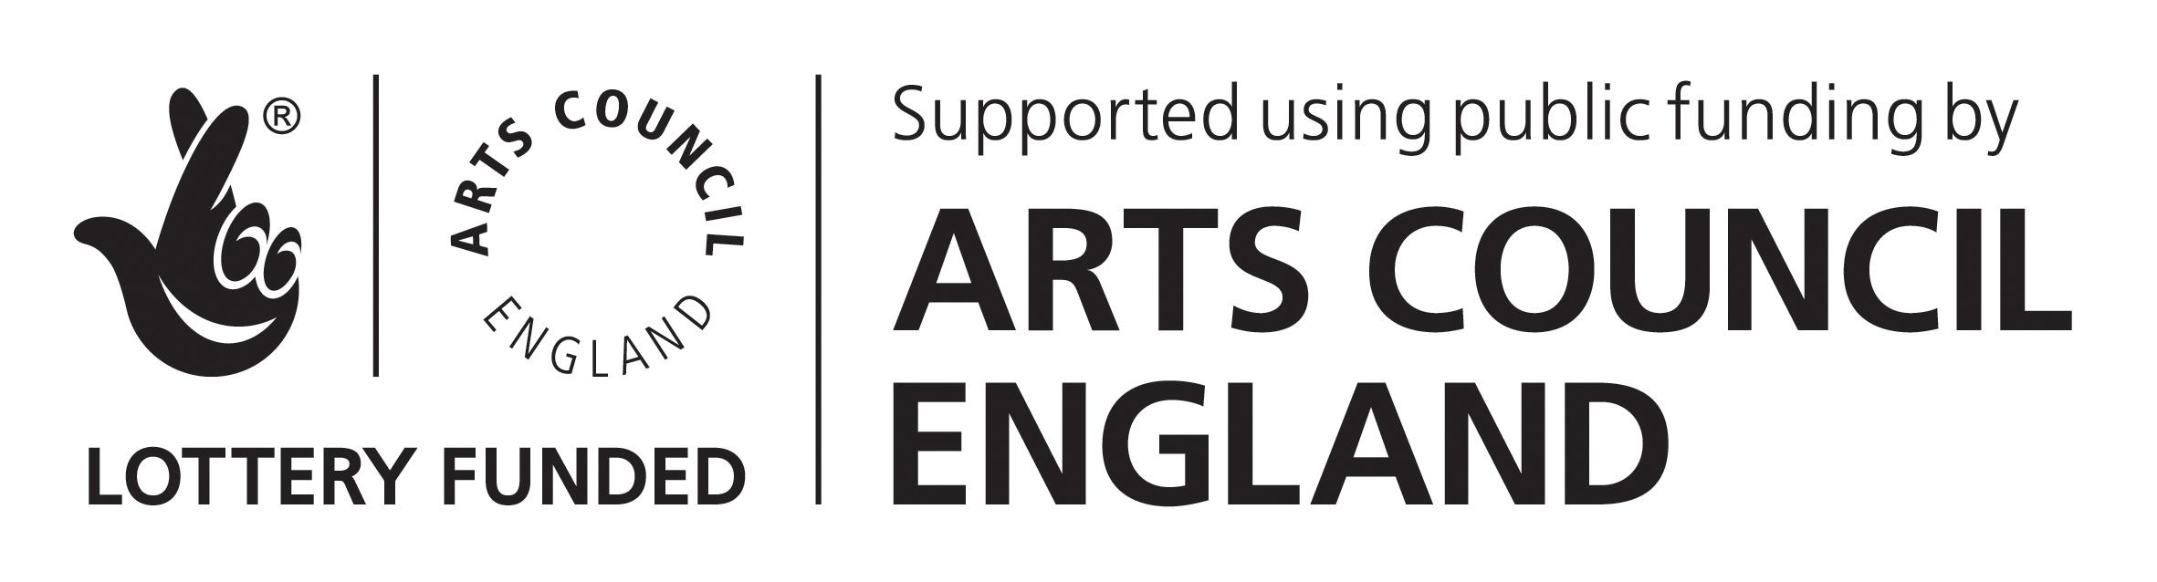

Role Title – PUSH Festival Assistant Internship

This opportunity

This is a great opportunity for someone age 18+ who is interested in exploring a creative career, with a particular interest in the planning and delivery of a cross-art form festival. This Internship role will give an insight into the work of HOME across all art forms and teams, as well as into the stages of preparing for and delivering a busy festival.

HOME is a multi-art centre, our two theatre spaces are a platform for playful, daring, new and commissioned work. Our five screens light up with independent, challenging, provocative film. The gallery is home to the very best in contemporary art. The restaurant offers a varied and delicious menu of food and drink.

As member of the team supporting HOME’s annual PUSH Festival, you will work closely with the PUSH Festival Producers. Within this Internship role you will support the PUSH Producers and the wider HOME team, to support the preparation and delivery of the festival.
PUSH Festival

PUSH 2018 will take place from Fri 12 – Sat 27 January 2018. Across the two weeks, HOME will be entirely dedicated to presenting inspiring, creative experiences fresh from the North West. Showcasing some of the most exciting film, theatre and visual arts from the region. PUSH Festival also offers great opportunities for artists and creatives to meet industry professionals, share ideas, inspiration and develop their skills across a broad range of topics with an array of workshops and events to get involved in.

Have a look at the PUSH Brochure here: https://homemcr.org/app/uploads/2017/10/PUSH-2018-Guide.pdf

Our Ideal PUSH Intern

We’re looking for someone aged 18+ who is looking for an internship in the creative industries. You will need to have an interest in culture and be keen to explore a career in the arts or in event production. You’ll also need to be interested in finding out more about the work HOME creates and presents.

You will have an interest in developing your skills in roles behind the scenes of an arts centre and in the production of a cross-art form festival. It will be great if you already have some understanding of working within or visiting an arts centre or live event venue. You will be keen to learn and experience more about how a festival such as PUSH is planned, developed and delivered. You’ll have a particular interest in exploring producing roles within the creative sector.

You will be keen to work with a wide range of HOME staff and be comfortable in meeting artists and the public.

You will need to be available to work within the timeframe set out in this document. Overall you will be a positive person, motivated and willing to get stuck in with duties as required.

Application Procedure

There are certain criteria you must meet in order to be eligible to apply for this Internship;
- At the time of applying you must be aged 18+
This Internship role is a work based training position and will support the ongoing development of PUSH Festival 2018.

Making an application:
To apply please contact ella.walker@homemcr.org for an application form

For an informal chat about your application, please contact Ella Walker on 0161 212 3456 or email ella.walker@homemcr.org.

GMAC is an equal opportunities employer, that is actively seeking to employ people currently under-represented in the creative and cultural sector. This includes young people, ethnic minorities and people with disabilities.

Thank you for your interest in this post.

Job Description for PUSH Festival Assistant Internship

Purpose

To work closely with the PUSH Festival Producers to ensure the planning, delivery and evaluation of PUSH Festival 2018.

This short term Internship role aims to provide an introduction to the variety of roles and duties which support the planning and delivery of a festival. Working with the Festival Producers, you will come into contact with various HOME teams and will gain experience of day to day life of cross-art form venue.

Responsible to: PUSH Festival Producers

Key Tasks/ Main Duties

- Communicating with PUSH Festival artists to coordinate and confirm key practical details, including rehearsal times, technical riders and risk assessments

- Providing general administrative services in support of the work of the festival including:
- internal circulation of information
- filing and general correspondence
- producing artists itineraries
- hospitality arrangement
- financial records keeping
- booking complimentary tickets for artists and guests
- compiling results of audience and artist survey

- Assisting the producers in the coordination and delivery of rehearsals, events and performances as required, including but not limited to:
  - Welcoming PUSH artists
  - Setting up spaces for workshops and events
  - Assisting the event producer with any duties required during the event such as guest’s hospitalities and audience support
- To work with the PUSH producers and the HOME Communications team to support and develop the reach of PUSH marketing, including researching best networks and promotional avenues, generating digital content and social media activities ideas and supporting the distribution of PUSH materials across the city

- To support the team in gathering feedback from PUSH companies post festival and all necessary post festival administrative duties.

- Other relevant duties as the PUSH team requires

TERMS AND CONDITIONS OF SERVICE

PUSH Festival Assistant Internship

GMAC Ltd has a Staff Manual that provides full details of all terms and conditions of employment as well as staff benefits. The following are the main terms of employment.

Salary £7.57 per hour

Hours of Work A maximum of 8 hours per day, inclusive of a one-hour break. Some evening and weekend work may be required during the festival

Contract Period Total hours of contract: 112
Starting: Week Commencing 4 December 2017
Ending: Week Commencing 29 January 2018

Provisional schedule as follows;
Pre-delivery schedule - 2 days per week for the following weeks commencing: 4 Dec, 11 Dec, 18 Dec 2017
Final dates to be confirmed with successful candidate

Festival delivery schedule – supporting the Festival period 12 – 27 January. Dates will be confirmed with the successful candidate and PUSH team during the pre-delivery phase

Holidays Holiday pay will be accumulated across the hours worked and included within the Internship wage

Introduction to HOME:
HOME is the trading name for Greater Manchester Arts Centre (GMAC).
In April 2015, HOME a new purpose-built centre for international contemporary art, theatre, film and books opened its doors for the first time in Manchester, as part of the vibrant new First Street development. From gallery to screen via café bar and bookshop, HOME redefines the contemporary arts centre, creating a space where ideas, hopes and moments of wonder ricochet off walls and lodge themselves in the headspace of audiences old and new.
Formed by the merger of two of Manchester’s best-loved arts organisations, Cornerhouse and the Library Theatre Company, the new organisation is a HOME for curiosity seekers, for lovers of the dramatic, the digital and the deeply engaging, for radicals and reciprocators.
HOME is a centre for co-production, artistic creation and sharing. Dedicated to learning, for people of all ages, a place for new work and playful ideas; of festivals and commissions; of artists and of audience engagement.

INTERNSHIP PERSON SPECIFICATION

 | Essential | Desirable
INTERESTS, DISPOSTION AND SPECIAL APTITUDES  SPECIALIST KNOWLEDGE  PRACTICAL SKILLS  PERSONAL CIRCUMSTANCES | Interest in the processes that support the running of a contemporary arts centre  Interest in festival production and programming  Enjoys variety and would welcome the opportunity to work with different aspects of the HOME programme  Friendly and open personality, able to communicate with a diverse range of people  Ability to work both as a team member and on own initiative  Good timekeeping and time management skills  Organised and motivated  Committed to the principles of equality and diversity  Proficient in Microsoft Office, particularly word and excel  Excellent communications skills, written & verbal  Use of emails  Ability to work flexible hours as required | Interest in contemporary theatre, art and film  Ability to work under pressure and multi-task to tight deadlines in a busy office  Experience of working in a cultural or creative environment (voluntary or paid) and/ or a knowledge of the (Manchester) creative sector  Some understanding of Health and Safety policies and procedures  Data Protection  Social media and website updating

